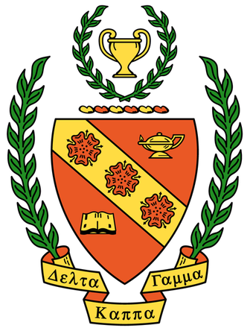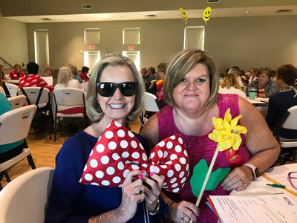

Initiation of New Members

Annually in May, new members are initiated into Gamma Epsilon Society.

Each year, the last weekend in April, Eta State holds an exciting, informative state convention. We enjoyed having our picture taken with the famous Leroy.

Eta State

North Carolina

Vision

“Voices of Influence . . .

Empowering Women Educator”

Motto

“Together we are Stronger.”

Committing

Collaborating

Celebrating. . . .

Projects and Fundraisers

Schools for Africa

Beginning Teachers

Christmas Charity

World Fellowship

Leadership Development

Scholarship Fundraiser

Gamma Epsilon has an annual scholarship fundraiser to raise money for recruitment grants for prospective educators interested in continuing to pursue their educational dream.

Gamma Epsilon

Chapter

of

The Delta Kappa

Gamma Society

International

Gamma Epsilon

Doing Our Part . . .

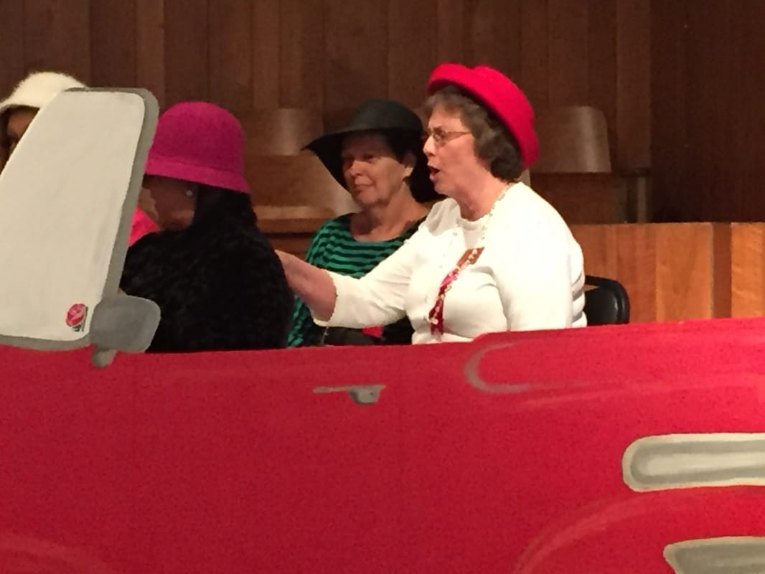

International Website

[www.dkg.org](http://www.dkg.org)

Eta State Website

[www.ncdkg.org](http://www.ncdkg.org)

Gamma Epsilon Website

[www.dkg-gammaepsilon.weebly.com](http://www.dkg-gammaepsilon.weebly.com)

**PURPOSES**

TO UNITE women educators of the world in genuine spiritual fellowship.

TO HONOR women who have given or who evidenced a potential for distinctive service in any field of education.

TO ADVANCE the professional interest and position of women in education.

TO INITIATE, ENDORSE, AND SUPPORT desirable legislation or other suitable endeavors in the interests of education and of women educators.

TO ENDOW scholarships to aid outstanding women educators in pursuing graduate study and to grant fellowships to non-member women educators.

TO STIMULATE the personal and professional growth of members to encourage their participation in appropriate programs of action.

TO INFORM the members of current economic, social, political and educational issues so that they may participate effectively in a world society.

**MISSION**

The Delta Kappa Gamma International and Gamma Epsilon Chapter Promote Professional and Personal Growth of Women Educators and Excellence in Education

What is Delta Kappa Gamma Society International?

The Delta Kappa Gamma Society International promotes professional and personal growth of women educators and excellence in education. The motto of this society is “Sharing our Vision – Strengthening our Society.”

What is Gamma Epsilon?

Gamma Epsilon is a local chapter of DKG that promotes the seven purposes of The Delta Kappa Gamma International and upholds their mission. As a vital part of the community, Gamma Epsilon members endorse leadership, recruitment and educational excellence.

Who are the Members?

The over 130,000 members include professional educators from all areas of education from both the public and private sector. Selection is based on professional qualifications, leadership potential and personal qualities.