Gamma Epsilon Expressions

*The newsletter of the Gamma epsilon chapter of the delta kappa gamma society international Eta state, north Carolina, region II, jones county*

**Volume 14, Number 1 September 2017**

# President’s message

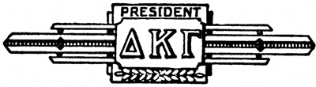

**Upcoming**

**Chapter Events**

DKG Meeting:

Thursday, September 14 at 4:30 for meeting and speaker. We will meet in the Jones Middle School Media Center.

**Upcoming**

**ETA State Events**

**April 27- 29 Eta State Convention in Charlotte at the Hilton Charlotte University Place**

July 16 – 20 International Convention at the JW Marriott Austin, Austin, Texas

\*\*Remember ALL sisters are asked to RSVP whether or not you will be attending the meetings. Please call Emily Andrews at (252) 521-3934 or email her at [esandrews0603@yahoo.com](mailto:esandrews0603@yahoo.com)

President of DKG Society International Carolyn Pittman’s theme for this biennium

*“DKG: Leading Women Educators Impacting Education Worldwide.”*

.

D

Gamma Epsilon Sisters,

Welcome back! I hope everyone had an exciting and restful summer. My summer however, was very busy. In an effort to prepare for the upcoming year, the Executive Planning Meeting was held in July. During this meeting, the board decided that we would continue to support new teachers and provide goodie supply bags for each of them around Valentine’s Day. This is the time of the year that many beginning teachers need a little extra morale boost to help them get through the remainder of the school year. We also provided breakfast for the New Employee Orientation on August 15, 2017 and several members were able to meet the new faces of Jones County Schools. As years in the past, we have supported the International Project – Schools for Africa. Since we have had great success with the “Dimes Drive” we will continue to fill water bottles and support Schools for Africa.

Our fundraiser for this year is a work in progress, but we will have our annual fundraiser again at the Lenoir County Shrine Club. We will be having dinner and entertainment, although the entertainment is in the works. We will hold our annual Fundraiser on March 10, 2018.

On to the state news, this year the Eta State Convention will be held in Charlotte on April 27 – 29.

I wish everyone a WONDERFUL year. Look forward to seeing everyone at our first meeting on September 14, 2017 in the Jones Middle School Media Center. Social time will be held at 4:15 and with the meeting beginning at 4:30.

Sincerely,

Michelle Basden

Gamma Epsilon President

*\*\*\*\*\*\*\*\*\*\*\*\*\*\*\*\*\*\*\*\*\*\*\*\*\*\*\*\*\*\*\*\*\*\*\*\*\*\**

*Dues are payable to Bea Harriett in September. Dues continue to be $65. If you are unable to attend the meeting you can mail your dues to Bea as soon as possible.*

**

*\*\*\*\*\*\*\*\*\*\*\*\*\*\*\*\*\*\*\*\*\*\*\*\*\*\*\*\*\*\*\*\*\*\*\**

DKG_RoseLogoLong3cSm

## **Eta State Updates and Information**

Gamma Epsilon Expressions Page 2 of 4

**Foundation Grants**

The submission window is open for grants through the NC DKG Educational Foundation. Applications are due **September 30.**

Six grants of up to $250 each will again be offered in the literacy/learning projects and the continuing education categories. Read about past awardees and their projects on the *Giving Page* of the Eta State [Educational Foundation](http://www.ncdkgef.org/) website.

Applications must be received no later than September 30, 2017. Announcement of grant recipients will be made by November 2017.Proposal Forms are posted on the Foundation website at <http://www.ncdkgef.org/>under the Grants tab.

**Mission Statement**

The Delta Kappa Gamma Society International promotes professional and personal growth of women educators and excellence in education.

DKG_Rose_Icon3cSm09

\*\*\*\*\*\*\*\*\*\*\*\*\*\*\*\*\*\*\*\*\*\*\*\*\*\*\*\*\*\*\*\*\*\*\*\*\*\*\*\*\*\*\*\*\*\*\*\*\*\*\*\*\*\*\*\*\*\*\*\*\*\*\*\*\*\*

Foundation Updates

***Roast for Betty Mccain***

The NC DKG Educational Foundation is sponsoring a Roast for Betty McCain as part of its major campaign fundraiser. The event will be held at the Wilson Community College’s Frank Eagles Business Center in Wilson on Saturday, September 23 from 5:00 – 7:00. Heavy hor d’oeuvres will be served. Tickets are $50 per person and may be purchased from Dot Carter (252-235-4515) or Betty Marshall (919-844-0313).

Look for more updates coming soon, including community involvement projects and a golf tournament.

**Eta State News**

The Eta State News Fall newsletter can be downloaded from the [website](http://www.ncdkg.org/uploads/8/0/8/5/80859646/eta_state_news_-_fall_2017_color_final.pdf). This edition is an online only newsletter.

Order your official DKG pin online at

<https://acgreek.com/greek/home.php>

Contact Information:



**Congratulations**

*Congratulations to Jackie Lanier in her new role as Instructional Coach for Grades 4-8 with Jones County Schools.*

*Gamma Epsilon President*

Michelle Basden

1835 Wise Fork Rd, Trenton NC 28585

252-571-7998

email: gmbasden95@gmail.com

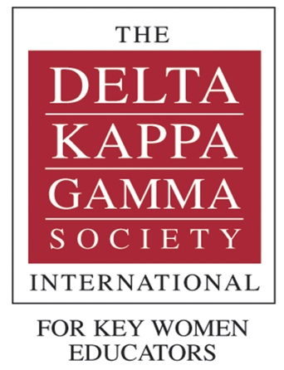

International Website

[www.dkg.org](http://www.dkg.org)

Eta State Website

[www.ncdkg.org](http://www.ncdkg.org" \t "_blank)

**October 21:** Bike Ride Fundraiser

**November 4:** Painting with Aunt Deb; Kinston

**December 14 at 4:30:** at Jones Middle School

**February 8 at 4:30:** Discuss fundraiser assignments/arrangements and distribute new member nomination forms.

**March 10: Fundraiser** details and information to be announced.

**April 14: Saturday meeting TBD** vote on new members and recap of fundraiser. Orientation for perspective members will be scheduled for late April.

**May 8:** Initiation of new members *at**Pollocksville Baptist Church;* dinner information TBA.



*If you have any stories or items to contribute to the newsletter, please send me an email or call. Any member news is greatly appreciated.*

**2015 – 2016 Gamma Epsilon Calendar of Events**

Gamma Epsilon Expressions Page 3 of 4

***Stay Connected***

***Our Eta State NC President***

***Connie Phifer Savell***

Encourages members to take better care of themselves and has focus for chapters of “Wellness Initiative 2017-2019”, She also encourages all members to SPARKLE!

Let’s SPARKLE! Goals include:

Encourage Savvy leadership

Inspire Passionate, meaningful programs and projects

Analyze and Articulate current educational issues

Further Respect for diversity in membership

Promote Knowledge through lifelong learning

Establish and Launch a member wellness initiative

Advocate Excellence in education

Final reminder that $65 dues are to be paid to Bea at the meeting or as soon as possible.

Newsletter Editor

Lorin Grimmett

(910) 389-4668

email:

lorin.grimmett@jonesnc.net

**Stay**

**Connected**

Social Media Information  
Join the conversations



[https://www.facebook.com/groups/EtaState/](https://www.facebook.com/groups/EtaState/" \t "_blank)

[*Tweets by @Eta\_State*](https://twitter.com/Eta_State)

Gamma Epsilon Website

<http://dkg-gammaepsilon.weebly.com/>



Gamma Epsilon Expressions Page 4 of 4

Photo gallery

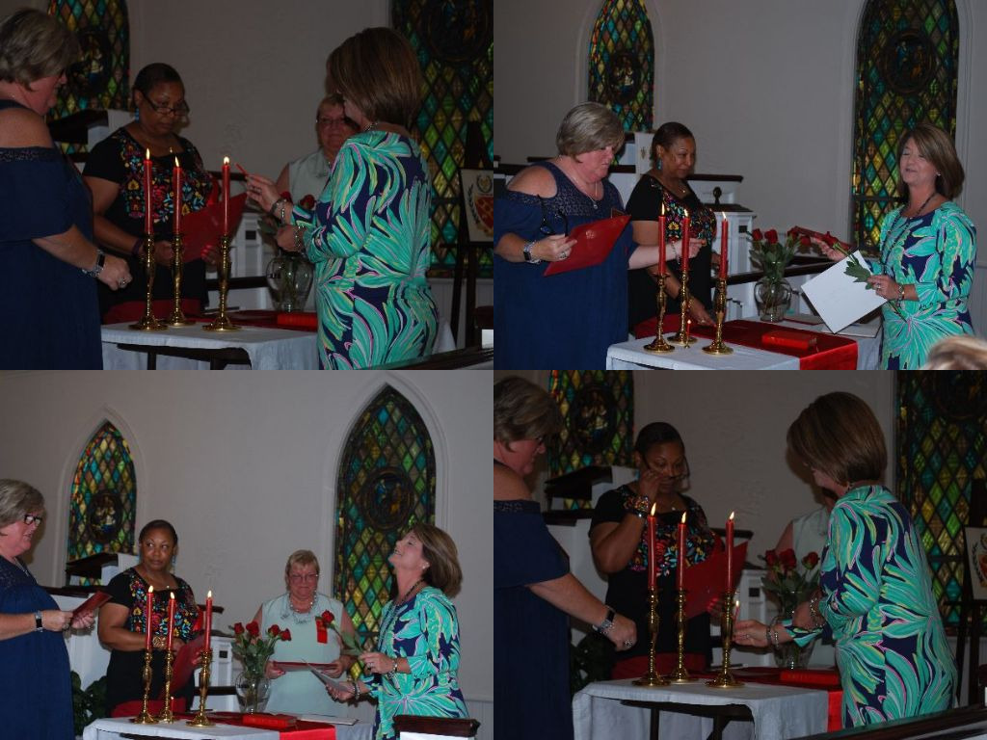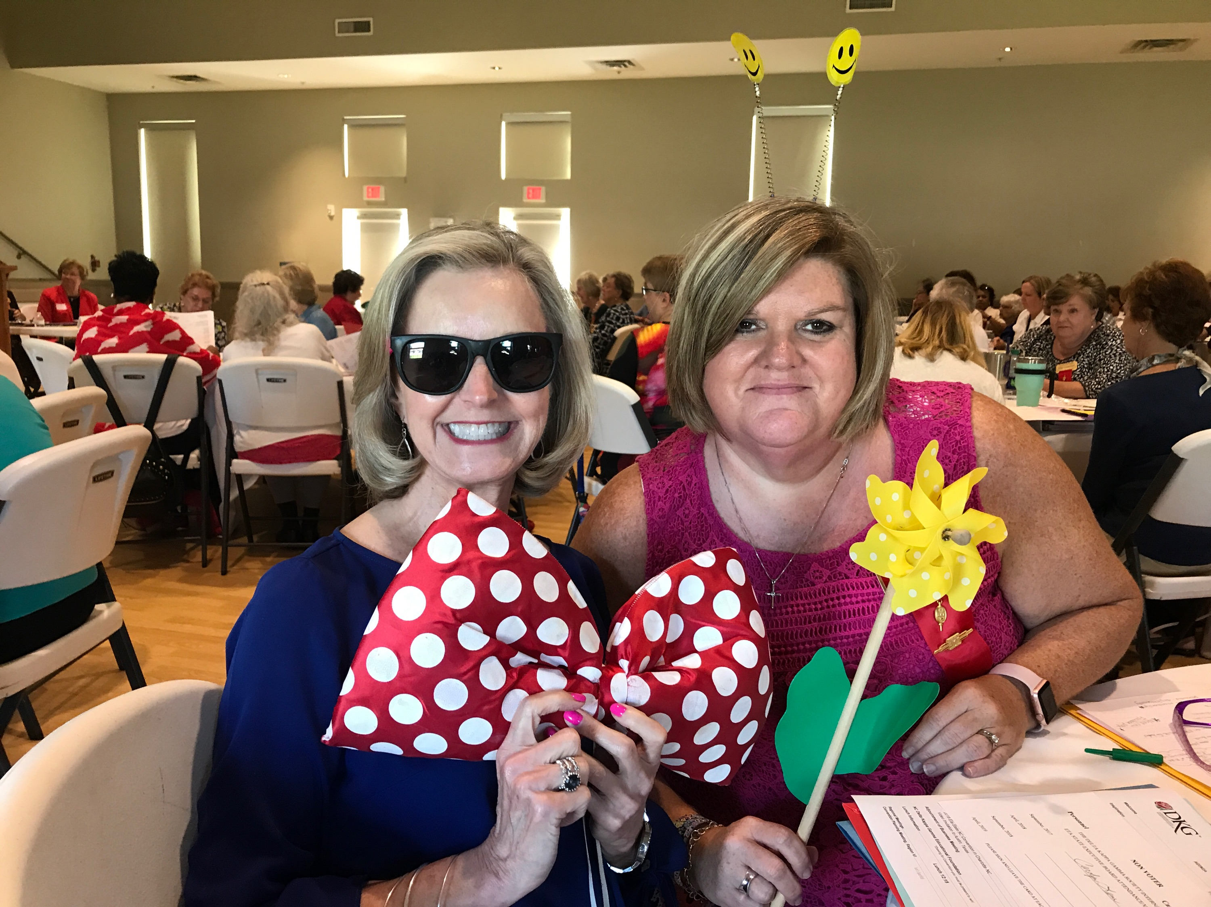

Gamma Epsilon Website

<http://dkg-gammaepsilon.weebly.com/>

*Top: Pictures from the Gamma Epsilon sponsored breakfast and gifts for Jones County School New Teacher Orientation.*

*Center – Pictures from the May recognition meeting and Initiation of new member Taffy Jones.*

*Left – Carolyn and Michelle at Eta State Fall Executive Board Meeting at Elon.*