**Volume 12, Number 1 September 2015**

*The newsletter of the Gamma epsilon chapter of the delta kappa gamma society international Eta state, north Carolina, region II, jones county*

Gamma Epsilon Expressions

# President’s message



**Upcoming**

**Chapter Events**

DKG Meeting:

December 3 at Jones Middle School Media Center at 4:30 – Cookie Exchange

**Upcoming**

**ETA State Events**

**April 22 - 24 Eta State Convention in Region IX Embassy Suites/Marriot Hotel, Winston Salem**

July 5 – 9 International Convention, Gaylord Opryland Resort & Convention Center, Nashville, TN

\*\*Remember ALL sisters are asked to RSVP whether or not you will be attending the meetings. Please call Emily Andrews at (252) 521-3934 or email her at [esandrews0603@yahoo.com](mailto:esandrews0603@yahoo.com)

President Sheila Groves’ theme

*“Create the Future — Imagine, Inspire, Ignite.”*

.

D

Dear Gamma Epsilon Sisters,

I hope you are enjoying getting to know your students this year!  The Gamma Epsilon Executive Board and members met this summer and have planned great programs and social opportunities for you!  Our first meeting will be on Sept. 22nd at the Jones Middle School Media Center.  Please plan to come at 4:15pm to enjoy fellowship, food, and fun with fellow members.  The meeting will start at 4:30pm with a short program about World Fellowship.  Please remember to pay your dues to Bea at this meeting ($65 check payable to: Eta State)

**Highlights of summer meeting:**

* In addition to receiving this newsletter via email, Emily Andrews has offered to print out and mail our Gamma Epsilon Newsletter to all members as well
* Would like to have a time for members to socialize at 4:15 before the meeting starts at 4:30.
* Continue with Spelling for Scholarships for our chapter's fundraiser.
* Have New Teacher bags given out in January to restock teacher's supplies.
* Continue to support Schools for Africa (collect dimes in water bottles; empty water bottle will be given out at Sept. meeting and bottle to be dropped off at May meeting)
* Membership Committee would like to see 25cents collected for members not wearing their pin.
* Order forms for pins, name tags, etc. to be available at Sept. meeting.
* Communications committee work on getting more publicity for our chapter by using several area newspapers.

I look forward to seeing everyone soon!

Jamie Waller

*\*\*\*\*\*\*\*\*\*\*\*\*\*\*\*\*\*\*\*\*\*\*\*\*\*\*\*\*\*\*\*\*\*\*\*\*\*\**

*A special thank you to everyone that contributed to the luncheon Gamma Epsilon hosted for the new hires of Jones County Schools. Several of our members volunteered their afternoon to come out and greet the teachers and talk with everyone in attendance. We received several compliments on the food and desserts. It was even a (+) on their chart at the end of the day. I think this was a great way to give to the teachers and show our support as they begin working in JCS. Great job ladies for making this endeavor a success in such a short amount of time!*

*Lorin Grimmett*

DKG_RoseLogoLong3cSm

## **Eta State Updates and Information**

Gamma Epsilon Expressions Page 2 of 5

**The 100 Challenge**

***Pay it Forward***

Now is the times to send in your donations for the **100 Challenge Pay it Forward** in support for the professional and personal development of women educators and excellence in education. Checks for your $10 pledge should be made payable to **North Carolina Delta Kappa Gamma Educational Foundation** and mailed to the foundation treasurer

***Betty Marshall***

***6212 Dresden Lane***

***Raleigh, NC 27612***

Jamie will also take any check she receives to the Fall Executive Board Meeting September 12. Contact Jamie for more information.

*Remember North Carolina Delta Kappa Gamma Educational Foundation is an approved 501 (c)(3) nonprofit organization, these are tax-deductible donations, and therefore checks are preferred.*

**Mission Statement**

The Delta Kappa Gamma Society International promotes professional and personal growth of women educators and excellence in education.

DKG_Rose_Icon3cSm09

\*\*\*\*\*\*\*\*\*\*\*\*\*\*\*\*\*\*\*\*\*\*\*\*\*\*\*\*\*\*\*\*\*\*\*\*\*\*\*\*\*\*\*\*\*\*\*\*\*\*\*\*\*\*\*\*\*\*\*\*\*\*\*\*\*\*

**Want to See the World with DKG?**

DKG has partnered with Go Ahead Tours to take DKG members on a fun, educational tour of England, Scotland and Ireland in mid-July, 2016. The 12-day itinerary is online at <http://dkg.grouptoursite.com>, along with an enticing slide show of points of interest along the way. Learn more by joining one of the webinars listed at [http://www.goaheadtours.com](http://www.goaheadtours.com/dkgwebinars)

Order your official DKG pin online at

<https://acgreek.com/greek/home.php>

## **LEROY The Leadership Guy**

**From http://leroytheleadershipguy.weebly.com/leroy-graphics.html**



Contact Information:



*Gamma Epsilon President*

Jamie Waller

202 Barkside Lane

252-229-7176

email: jamwaller2@yahoo.com

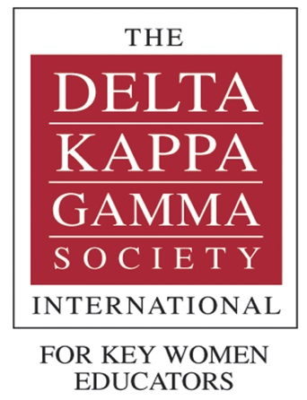

International Website

[www.dkg.org](http://www.dkg.org)

Eta State Website

[www.deltakappagamma.org/NC/](http://www.deltakappagamma.org/NC/)

**2015 – 2016 Gamma Epsilon Events and meeting schedule**

*If you have any stories or items to contribute to the newsletter, please send me an email or call. Any member news is greatly appreciated.*

**September 22:** Program “World Fellowship” Hosts: Aileen, Megan, Donna, Lorin, Stella \*\*Pay dues $65

Location: Jones Middle School Library

**November TBA:** Shopping at Lynn Faulk’s to support Christmas Cheer (look for more information in the upcoming weeks)

**December 3:** Social “Holiday Treat Exchange” Hosts: Trenton Elementary Staff Time/Location: 4:15, Jones Middle School Library \*\*Bring a tin of cookies or holiday treat to share and bring another tin to take home other’s treats\*\*

**January 7:** Program: Eta State President Sheila Groves to visit, **new teacher bags (staff new to Jones County),** fundraiser assignments, new member forms Hosts: Maysville Elementary Staff Time/Location: 4:15 Jones Middle School Library

**February 11:** Spelling for Scholarships (date pending approval) at Jones Senior High

**March 19, 10:00 am:** Vote on new membership Hosts: Carolyn and Kelly Location: Breakfast at Baker’s Kitchen in downtown New Bern

**April (TBD):** Orientation for new members

**May 17 5:30:** Initiation of new members Hosts: retired teachers Location: Pollocksville Baptist Church

***Stay Connected***

**Stay**

**Connected**

**

There is much to explore in this online-only issue of *DKG News*, including the announcement of Sandra Smith Bull as the new Executive Director of DKG and *It’s Complicated: The Social Lives of Networked Teens* as the 2015 Educators Book Award winner, and part two of Dr. Schmid’s president’s column about her webinar conversation with GenY members.

It also includes an article on membership, a list of the Cornetet and Educational Foundation award winners (including our NC winners), and a recap of the May 2015 executive board meeting actions.

You can view the entire newsletter online at <https://www.dkg.org/sites/default/files/files-for-download/2015_NEWS_Jul-Aug.pdf>

Social Media Information  
Join the conversations on:

[https://www.facebook.com/groups/EtaState/](https://www.facebook.com/groups/EtaState/" \t "_blank)

[*Tweets by @Eta\_State*](https://twitter.com/Eta_State)

Newsletter Editor

Lorin Grimmett

(910) 389-4668

email:

lorin.grimmett@jonesnc.net

Gamma Epsilon Website

<http://dkg-gammaepsilon.weebly.com/>

Gamma Epsilon Expressions Page 3 of 5

**Meeting Minutes May 7, 2015**

**Submitted by Carolyn Lane (acting secretary for Megan Phillips)**

Gamma Epsilon Expressions Page 4 of 5

* Gamma Epsilon welcomed our new sister, Julie Mercer at an initiation ceremony. The members sang The Delta Kappa Gamma song. Also honored were sisters that had 25, 30, 35, and 40 years of DKG Membership. Each of the following honorees received a pin signifying the number of years as members:
* Polly Whitehead, 25 years Cathy Waters 30 + years
* Mary Thomas, 30+ years Agnes Phillips, 35 years
* Lottie Bonner, 35 years Sylvia Miller, 40 years
* Carol Hood, 40 years

Sylvia Miller and Carol Hood, charter members of Gamma

Epsilon were given a crimson rose.

* Jamie Waller called the meeting to order and Diane Bell shared the COLLECT.

**Society Business:**

* The president advised that the minutes for March 5th and May 7th would be in the upcoming newsletter.
* Bea Harriett gave the treasurer’s report. The total balance for March 12,2015 was $4528.14, the disbursements since March 12th was $917.34 and the balance on hand as of May 7, 2015 is $3610.80. In savings we presently have $5282.16.
* The present Spelling Bee Fundraiser profit was $3402.17 including the expenses of the gift cards for JSHS custodial staff. Bea Harriett made a motion, which was seconded by Donna Morton, that $3000 of the $3610.80 be put into savings. The motion carried.

**Society Mission and Purpose:**

* President Waller indicated that information was provided on a table related to the Leadership Development Seminar at Peace College in June.
* Members paid $1.00 to share a “Happy Moment” with the sisters. These monies go to the World Fellowship fund.

**New Business:**

* JoAnn Stone presented the following candidates for scholarships: Rachael Martin a sophomore at Meredith College seeking licensure as a teacher in K-12 Spanish; Ashley Andrews a graduate of NCSU and presently a social worker is pursuing a degree in counseling at ECU. Jo Ann Stone made a recommendation from the committee that each candidate be given a $1000 scholarship. The members voted approval.
* President Waller shared informationfrom the Eta State Convention. The meeting was adjourned and the members moved to the fellowship hall for dinner.

**Gamma Epsilon Expressions**

Gamma Epsilon Expressions Page 4 of 5

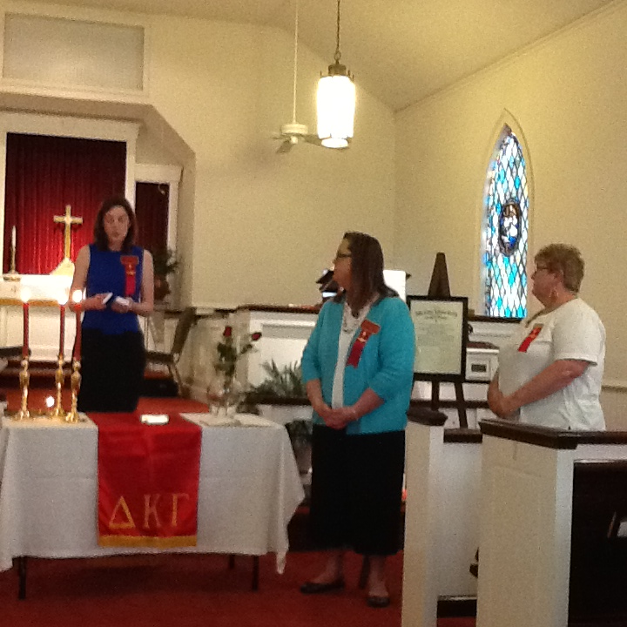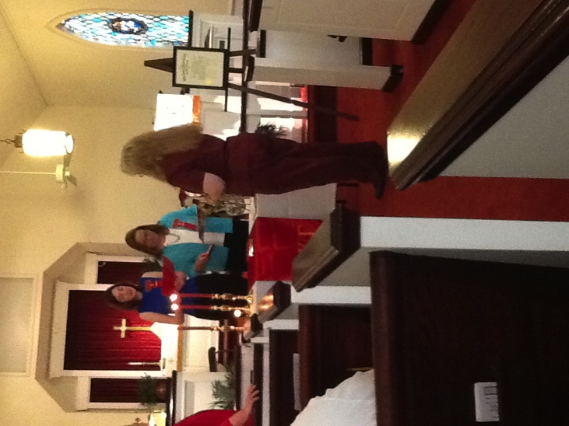

Left: Initiation of New Member Julie Mercer

Right: Current and past 2 Presidents of Gamma Epsilon Chapter of DKG

Below: Mary Thomas receiving her 30 Year Membership pin

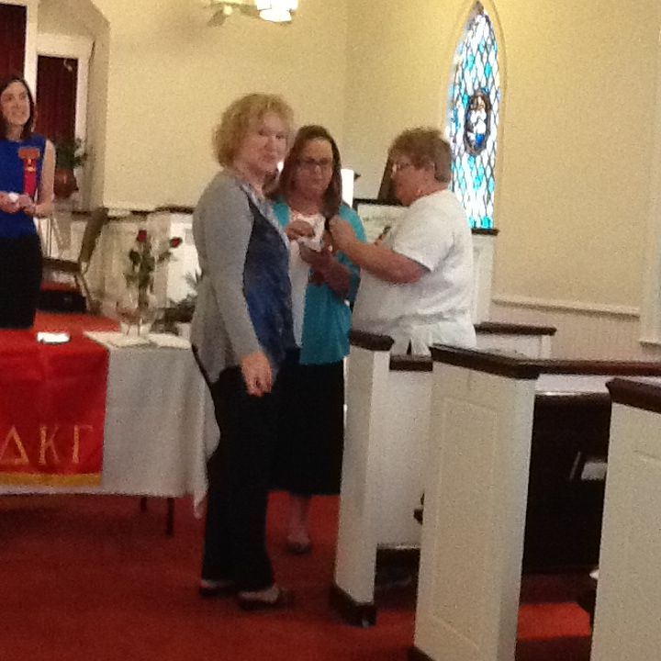

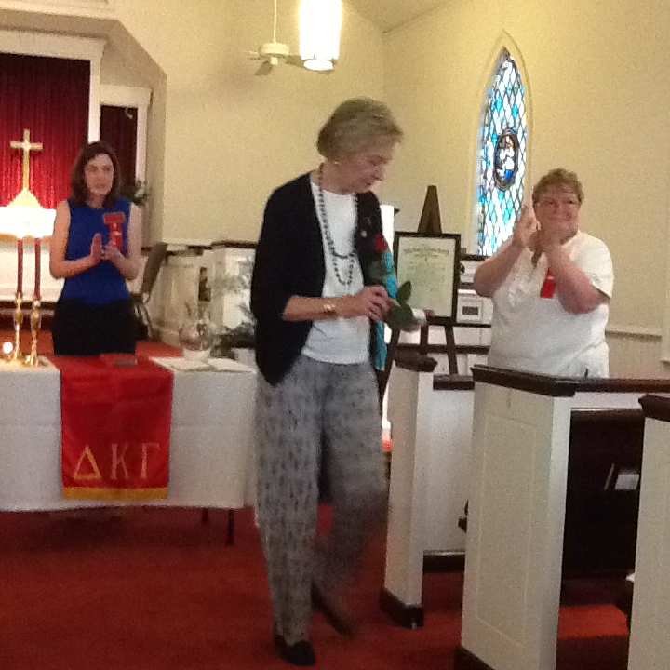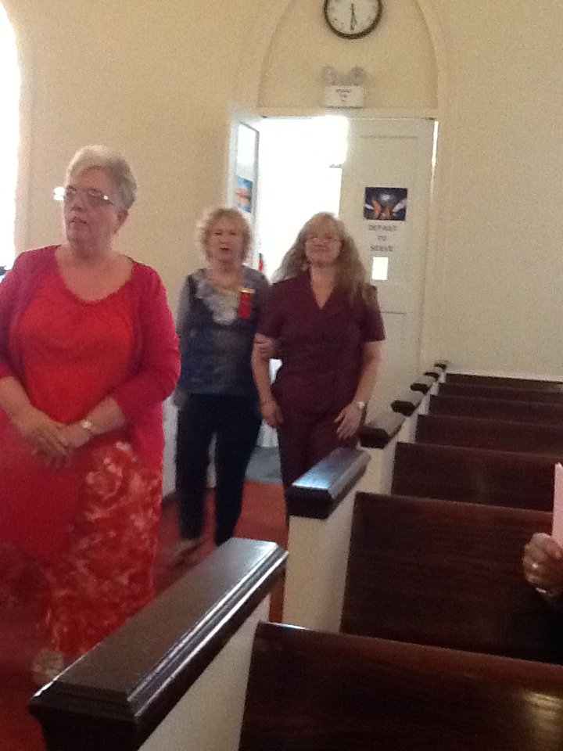

Lunch provided for New Teacher Orientation

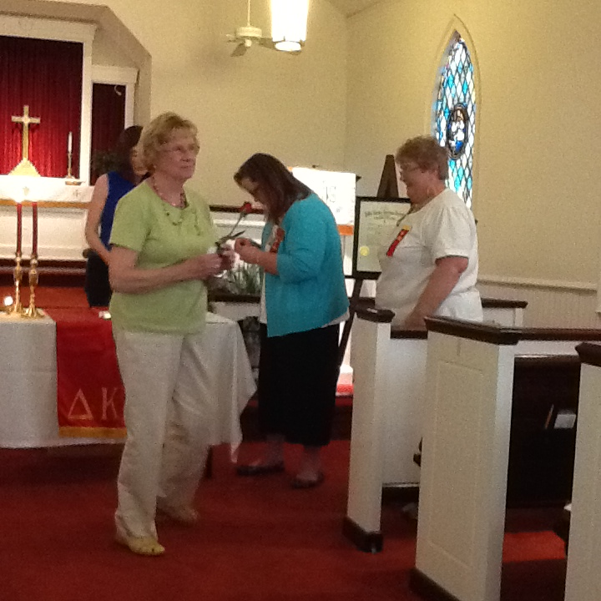





Carol Hood (left) and Sylvia Miller (above) after receiving their 40-year Membership pins and crimson rose.